Legal Researchers

2020

International Human Rights

Activities Report

16 Days Activism Activities

**Table of Content:**

Preamble--------------------------------------------------------------------------------------------------------------------------

Precursors of 20th Century Human Rights--------------------------------------------------------------------------------

Day First, December 1, 2020-------------------------------------------------------------------------------------------------

Day second, December 3, 2020---------------------------------------------------------------------------------------------

Day third, December 7, 2020------------------------------------------------------------------------------------------------

Day fourth, December 9, 2020----------------------------------------------------------------------------------------------

Day fourth, December 9, 2020 Second activity--------------------------------------------------------------------------

Day fifth, December 10, 2020------------------------------------------------------------------------------------------------

Day Fifth, December 10, 2020 Activity two-------------------------------------------------------------------------------

Day Fifth, December 10, 2020-----------------------------------------------------------------------------------------------

December 10, International Human Rights Day New York------------------------------------------------------

Videos Links-----------------------------------------------------------------------------------------------------------------------

**Preamble**

The belief that everyone, by virtue of her or his humanity, is entitled to certain human rights is fairly new. Its roots, however, lie in earlier tradition and documents of many cultures; it took the catalyst of World War II to propel human rights onto the global stage and into the global conscience. Throughout much of history, people acquired rights and responsibilities through their membership in a group – a family, indigenous nation, religion, class, community, or state. Most societies have had traditions similar to the "golden rule" of "Do unto others as you would have them do unto you." The Hindu Vedas, the Babylonian Code of Hammurabi, the Bible, the Quran (Koran), and the Analects of Confucius are five of the oldest written sources which address questions of people’s duties, rights, and responsibilities. In addition, the Inca and Aztec codes of conduct and justice and an Iroquois Constitution were Native American sources that existed well before the 18th century. In fact, all societies, whether in oral or written tradition, have had systems of propriety and justice as well as ways of tending to the health and welfare of their members.

**Precursors of 20th Century Human Rights Documents**

Documents asserting individual rights, such the Magna Carta (1215), the English Bill of Rights (1689), the French Declaration on the Rights of Man and Citizen (1789), and the US Constitution and Bill of Rights (1791) are the written precursors to many of today’s human rights documents. Yet many of these documents, when originally translated into policy, excluded women, people of color, and members of certain social, religious, economic, and political groups. Nevertheless, oppressed people throughout the world have drawn on the principles these documents express to support revolutions that assert the right to self-determination.

**16 DAYS OF ACTIVISM AGAINST GENDER VIOLENCE**

Despite the many democratic advances in a region historically wracked by the violence of Women, gender violence remains one of the most flagrant violations of human rights and impediments to equality between women and men all over the world. Over the last decade, LR has worked with government and civil society partners in popularizing the sixteen days of activism to end Gender Violence that is now a formidable and well recognized regional campaign. Over the last four years, LR has successfully piloted a comprehensive set of prevalence survey, better use of administrative data, media and discourse analysis, and qualitative tools. The foremost defy include plans that have been developed have remained national policy documents without filtering to other levels, particularly communities.  Until the piloting of the GBV indicators project, these plans also lacked effective ways of establishing baseline data and tracking progress. And the plans have tended to place a heavy emphasis on response and support, rather than prevention. Such strategies also tend to view women as hopeless victims, rather than survivors who have agency, hopes and aspirations.

At the local level the 16 Days creates a concrete link between national policy initiatives and the practical implementation of strategies to address GBV in communities. The project builds on several years’ work on gender and local government to challenge the prevailing assumption that GBV is not a local level competence. It demands gender responsive governance at all levels in challenging the most flagrant human rights violation in the region. Besides that at a realistic level many of the conditions that source women to be unsafe such as poor lighting, lack of security in public spaces, naming streets, lack of basic services: water, electricity and sanitation are controlled by local government. At a systemic level local government needs to place to make the environment safe and secure for women. LR is working with local actors to ensure such practical implement.

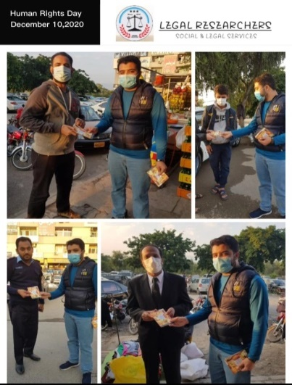Legal Researchers has scheduled different activities with youth, children's, elderly age, daily worker women and session with public at large for their thoughts on the Human Rights and their basic rights. The Human Rights activities conducted at Islamabad, Rural areas, Manhattan, New York city starts from December 1, 2020 till end December 10, 2020. The session’s participant in groups, not more than 10 individuals in each session/activity.

**Day First, December 1, 2020:**

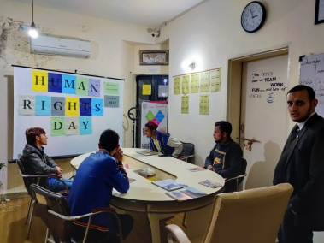A session with LR youth volunteers on the Human Rights and available procedure for availing the services of Basic rights, procedure of civil documentation and structure of Legal Remedies. In the session 9 participants attended the session 5 men and 4 women at Islamabad office G-11/3. At the end of session Human Rights booklets distributed and for onward provided 30 sets distribution also human rights books disseminated.

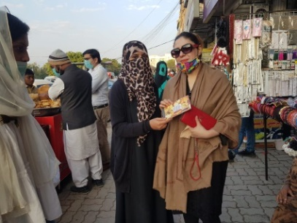**Day second, December 3, 2020:** A session with working women conducted, at the end of session group exercise also conducted. Few of women shared their lives experiences and their success. The women elaborated that how they proud to support their families. In the session 16 women has participated. 16 handouts also distributed 30 sets have been taken for family members and relatives.

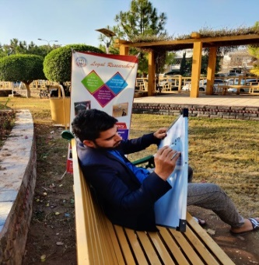**Day third, December 7, 2020:** LR team organized session with Public views 83 participants 23 women and 60 men for better understanding on Human Rights and basic constitution of rights. The activities conducted at Sector G-11 nearest park at G-11 commercial market. The larger group shared their thoughts and explained why the Human Rights are important. How it impact on Access to justice.

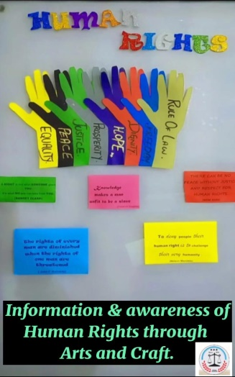**Day fourth, December 9, 2020:** The walking interviewswere organized including the police officials, public common men, women, shop keepers and daily wagers 77 total including 53 men and 24 women . IEC material of human rights in shape of booklets was also disseminated to them for information sharing at large.

**Day fourth, December 9, 2020:** There was another activity done with the children of community to display Art & Craft activity through different charts in the Premises of Legal Researchers Firm G-11/3 Islamabad, Pakistan.

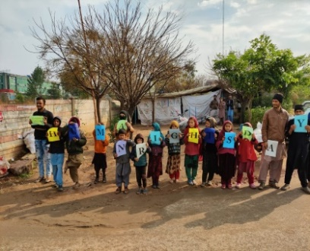**Day fifth, December 10, 2020:** An peace walk has been conducted with the children out of schools and youth during the day and parents of kids have orientation session with 22 participants 9 girls and 13 boys and to give message of peace on earth that rights are equal for all without any discrimination of gender, race, ethnicity and religion. There was another activity held with 31 children presented Art and Craft to display the Human Rights messages with coloration of LR staff member at Islamabad, Pakistan.

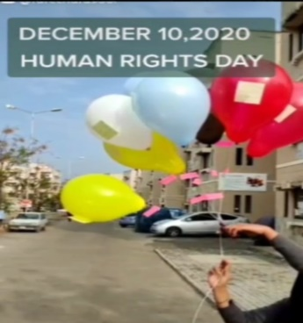**Day fifth, December 10, 2020:** There was another activity held on the same day different Human Rights messages were written on balloons that were winged up in the air which was one of the effort in order to spread the Human Rights messages where every the balloons reach.

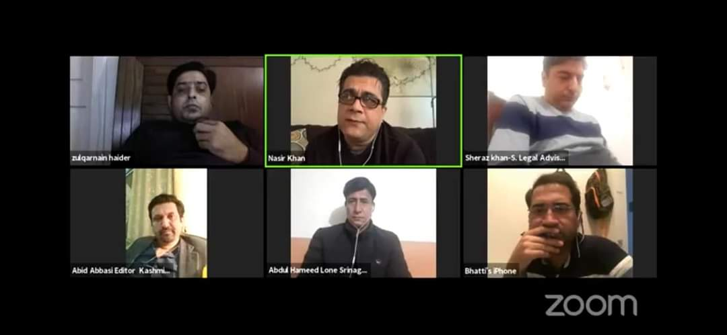**Day Fifth, December 10, 2020**: The LR team had activity with 9 Sikh communities at New York, sharing of thoughts on freedom of speech, education and other greatness. The Zoom meeting was also arranged with participants of 30 individual’s media personals and Human rights activist. Mr. Afazal butt, Asif bhati, Tariq Choudry explained the density of important issues. Mr. Zulqarnain, TP Singh, Abdul Hameed from media shares their view. Mr. Sheraz khan, Executive Director, LR expressed explained in the context of Human Rights legal frame work. He emphasized on the restrictions freedom of speech, freedom of expression and denial of access to their rights.

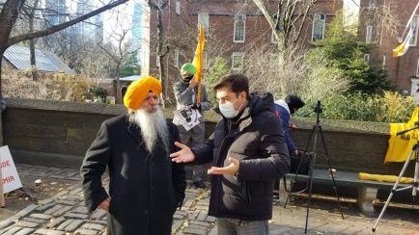**December 10, International Human Rights Day New York:**

Mr. Sheraz khan- Snr. Legal Advisor, shared dialogues with Dr.Amarjit Singh on Human Rights Day regarding the India constitutions article 19, guarantees six fundamental freedoms to citizens including freedom of movement, freedom of profession, occupation, trade or business, and others. 'International human rights law is the body of international law that seeks the protection of rights that are inherent to the human person, Human rights are the basic rights and freedoms that human beings are entitled to International human rights law seek to ensure human rights to all human beings without any discrimination. IHL applies to both state and non-state actors, it remains contested whether and under what circumstances, non-state actors have human rights obligations. Human rights law applies at all times.

**Black Day marked at history calendar"**

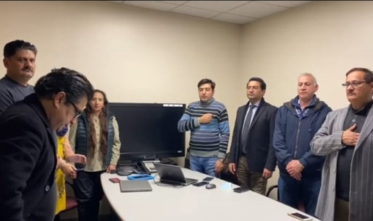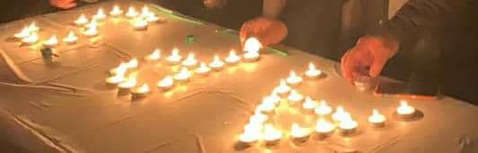OPGF with collaboration LR had conducted activity, Dec 16 at New York, for taking part in the anguish of Army Public School little angles martyrs. We stand for Human Rights and condemn such a cruel act never happens in history. The group discussed, the Role of Mother, whom always given sacrifice’s for Nation and make a Society. Mr. Asif Ali Bhatti, Snr. Voice president RIUJ explained teacher

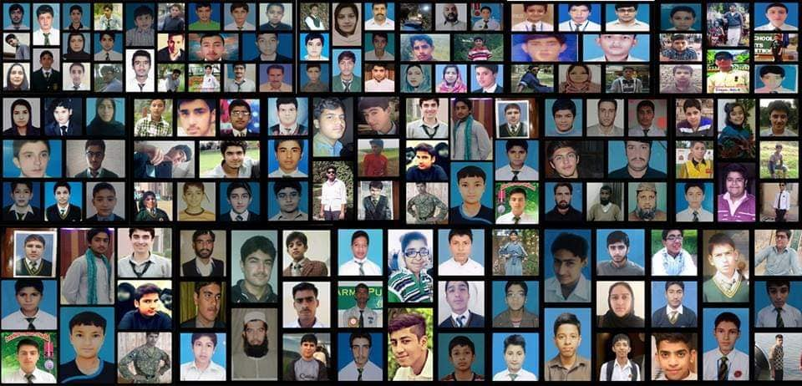Role and his/her contribution. Mr. Zahir Maher shared overseas commitment to support the youth to continue their education. Mr. Nasir qayyum, Mr. Javid Butt, Ms. Fouzia and other participants share their views. Mr. Sheraz khan, Snr Attorney hosted the event and elaborated role of state and plea to Govt of Pakistan award 144 children murdered at APS incident. Participants on zoom Expressed grief. During event, the brave martyrs were sacrifices in the name of patriotism.

Mr. Hanzala, a young survivor of APS who has made himself a role model to rest of new students in the momentum of black Day Dec 16, 2020 Peshawar.

He has shared his courageous story and grief faced in the period of brutality time in incident happened.

The session end on National anthem and solute to all APS Angels.

**Videos Links:**

<https://youtu.be/2ElY7oF4Ybo> -Public View Recorded December 9, 2020

<https://youtu.be/4rlCXNSJG84-Session> with Volunteers on Human Rights

<https://youtu.be/3EVQxjToU7w> -Billion Exercise for Peace Building

<https://youtu.be/TF33SnbUGOc-> Session with elder-age Group.